

BIT 4107 – Mobile Application Development
ENHANCED PROFESSIONAL STUDENT LOGBOOK
Student Name: SHEILA WAITHERA MURIITHI
Admission Number: BIT/2024/32455
Academic Year: YEAR 4
Semester:SEM II
Lecturer:Mr.Nyoro

Table of Contents
WEEK 3 ASSIGNMENT 3
Build a Complete UI Prototype 3
Login / Sign In 4
Registration / Sign Up 4
Home Dashboard 4
Prescription Upload / Order Page 5
User Profile Screen. 5
Navigation working 6

WEEK 3 ASSIGNMENT

Build a Complete UI Prototype
Requirements:
- 5 Screens minimum
- Navigation working
- Responsive design
- Modern UI
- Functional forms
Tools:
- Figma + Flutter or React Native

5 screens Minimum

Login / Sign In
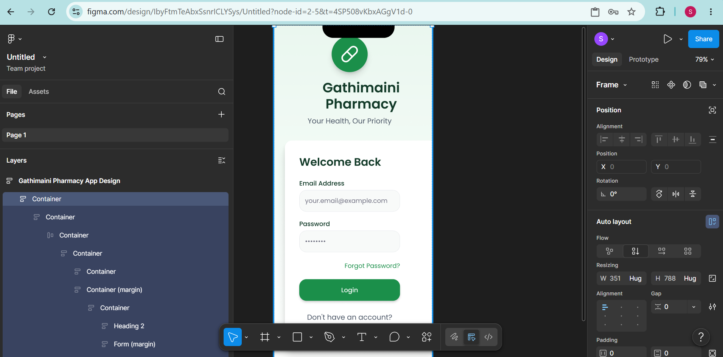

Registration / Sign Up
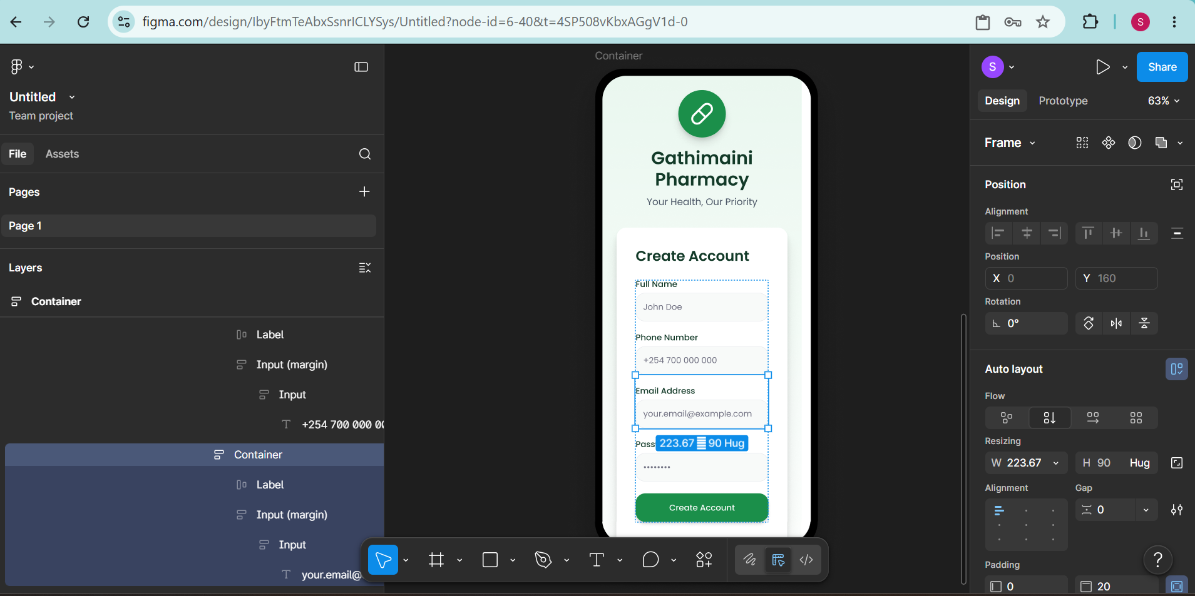

Home Dashboard

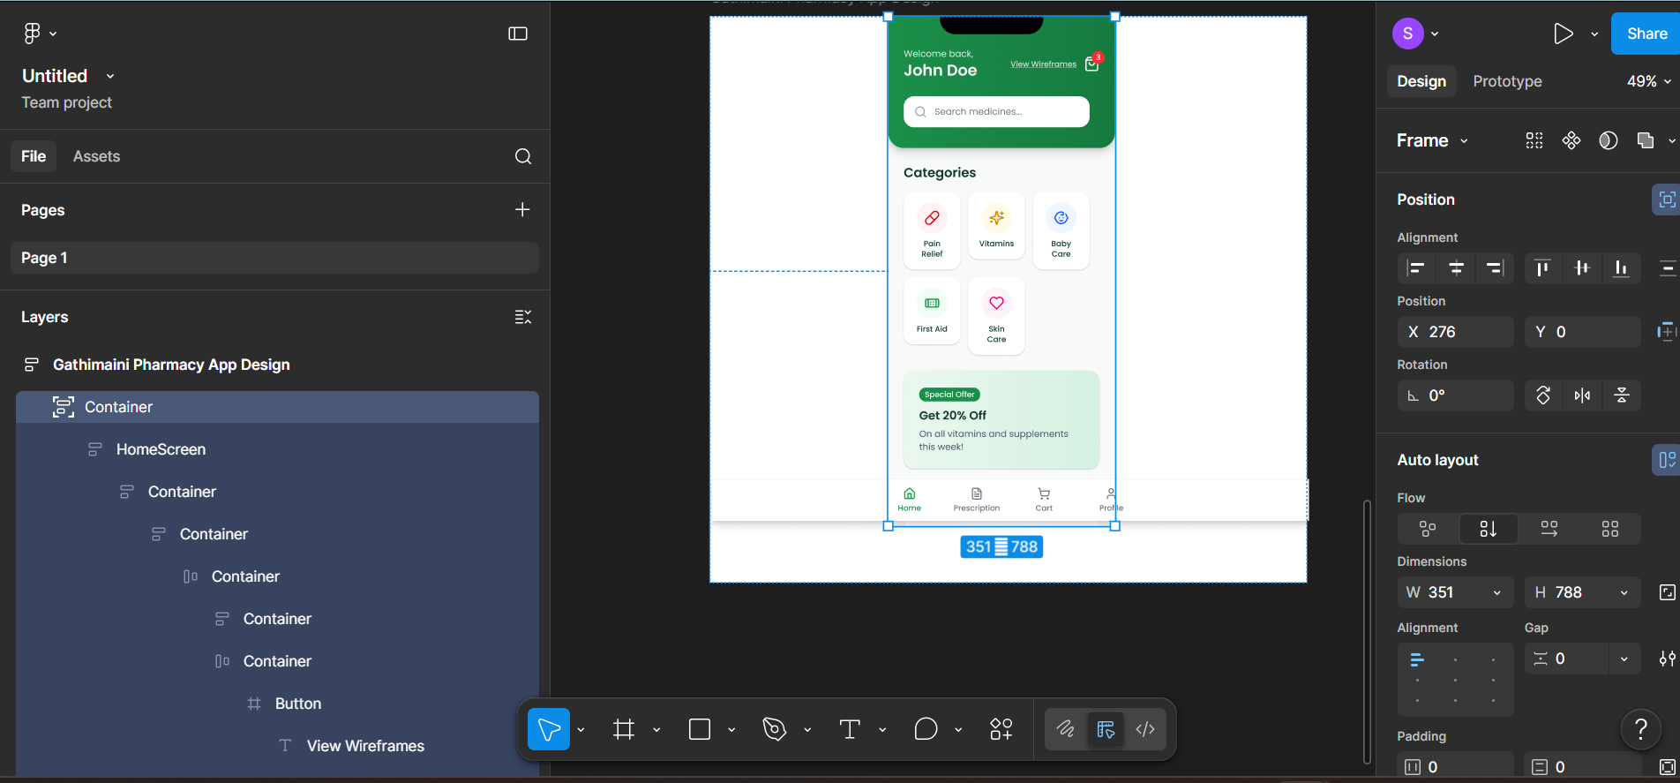

Prescription Upload / Order Page
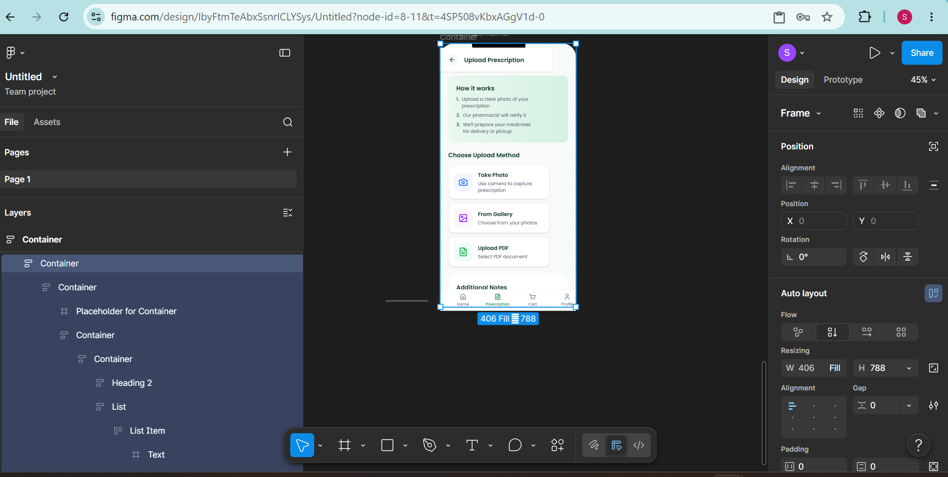

User Profile Screen.
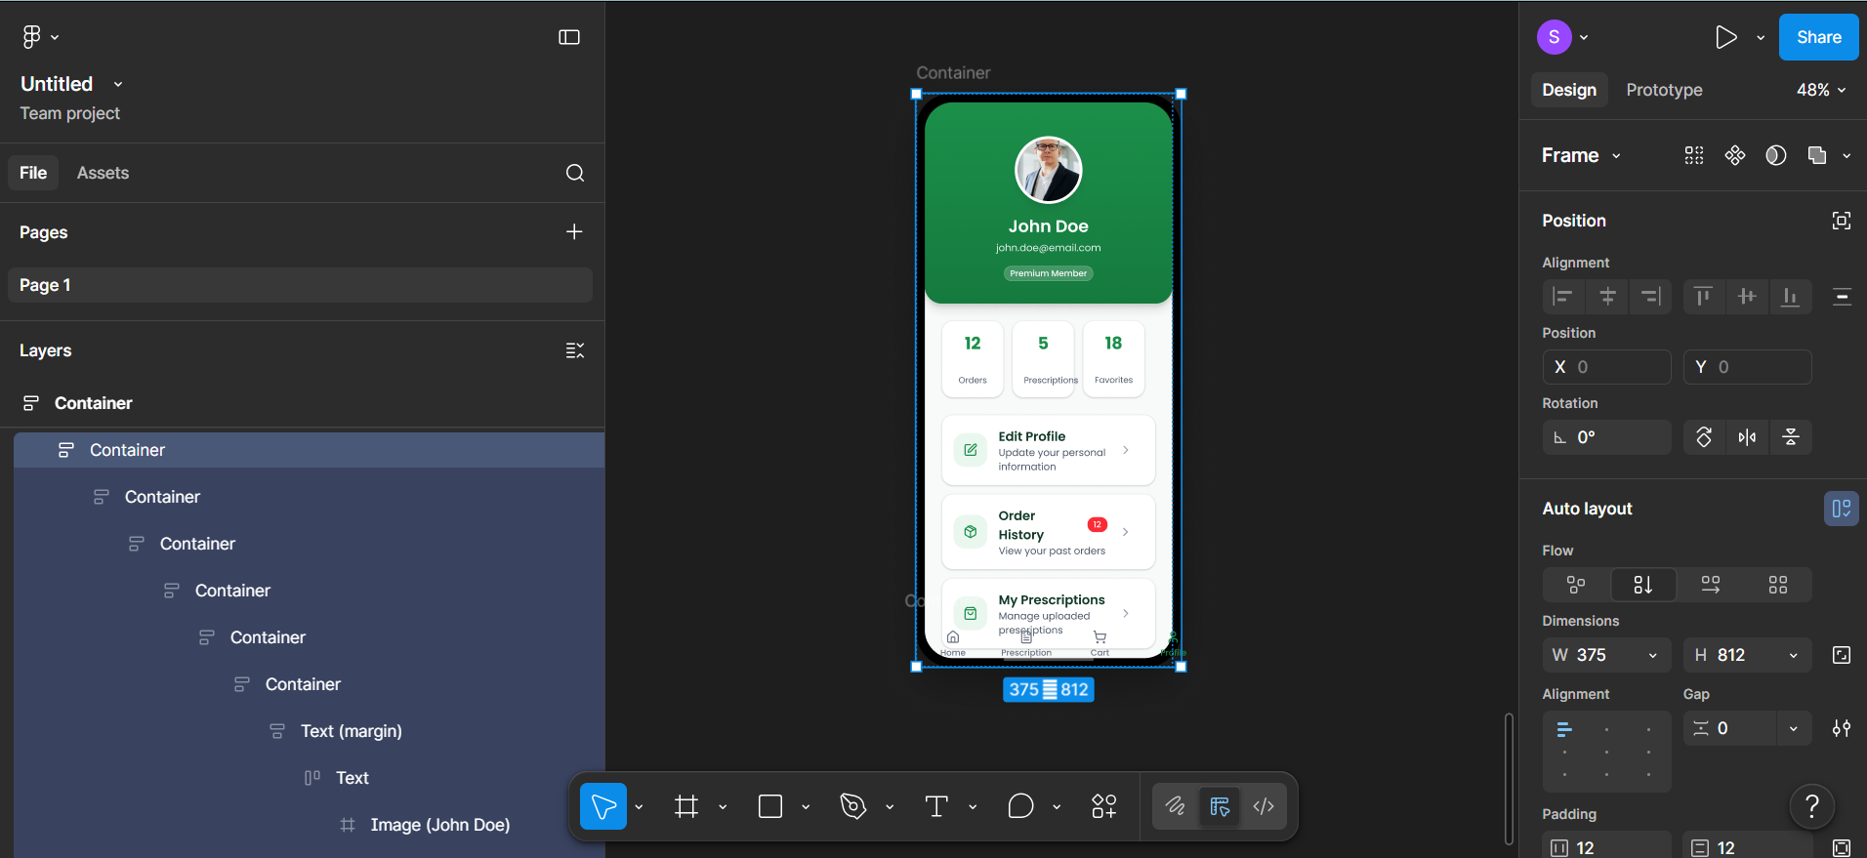

Navigation working
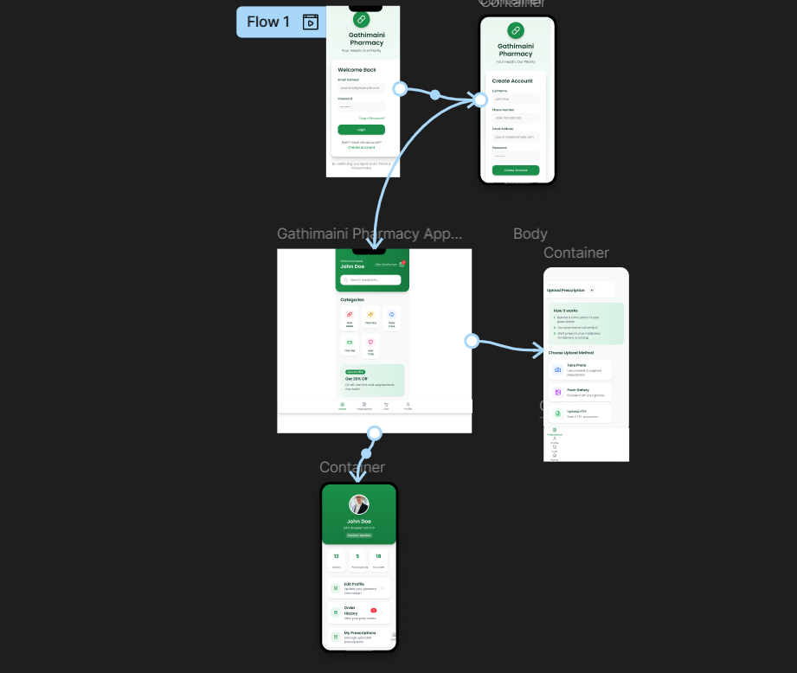

Tool used:
Week 3
Figma: A collaborative interface design tool. It was used to build the complete UI prototype for the "Gathimaini Pharmacy App," specifically designing the 5 required screens.

Personal Reflection

Week 3: UI/UX Prototyping
- Designed a comprehensive 5-screen Figma prototype for the Gathimaini Pharmacy App.
- Structured the visual hierarchy for the authentication flow, including Login and Create Account screens.
- Mapped out the core user journey through a main home screen, a prescription upload interface, and a user profile menu.

